M.s.sanjay
15bce0517
Activity-4

Decision tree:

> dataset=read.csv('/home/sanjay/Desktop/Machine Learning A-Z Template Folder/Part 3 - Classification/Section 19 - Decision Tree Classification/Decision_Tree_Classification/Social_Network_Ads.csv')
> View(dataset)

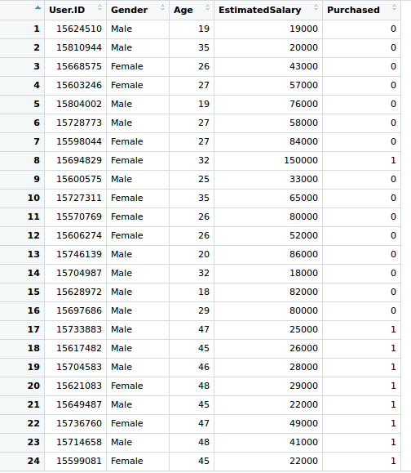

> dataset = dataset[3:5]
> dataset$Purchased = factor(dataset$Purchased, levels = c(0, 1))
> library(caTools)
> set.seed(123)
> split = sample.split(dataset$Purchased, SplitRatio = 0.75)
> training_set = subset(dataset, split == TRUE)
> test_set = subset(dataset, split == FALSE)

> training_set[-3] = scale(training_set[-3])
> test_set[-3] = scale(test_set[-3])

SCREENSHOT OF TRAINING SET AFTER FEATURE SCALING:

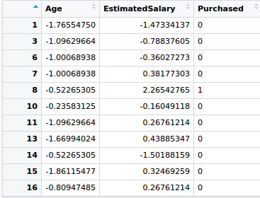

SCREENSHOT OF TEST SET AFTER FEATURE SCALING:

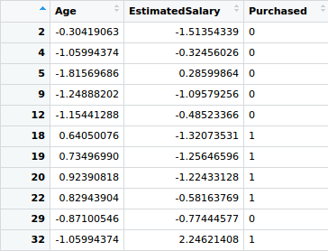

> library(rpart)
> classifier = rpart(formula = Purchased ~ .,
+ data = training_set)
>
> y_pred = predict(classifier, newdata = test_set[-3], type = 'class')
> y_pred

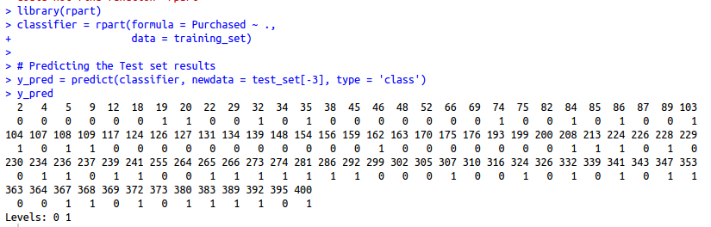
CONFUSION MATRIX

> cm = table(test_set[, 3], y_pred)
> cm

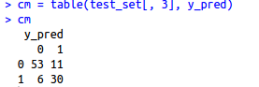

> library(ElemStatLearn)
> set = training_set
> X1 = seq(min(set[, 1]) - 1, max(set[, 1]) + 1, by = 0.01)
> X2 = seq(min(set[, 2]) - 1, max(set[, 2]) + 1, by = 0.01)
> grid_set = expand.grid(X1, X2)
> colnames(grid_set) = c('Age', 'EstimatedSalary')
> y_grid = predict(classifier, newdata = grid_set, type = 'class')
> plot(set[, -3],
+ main = ' 15BCE0517-Decision Tree Classification:Training set',
+ xlab = 'Age', ylab = 'Estimated Salary',
+ xlim = range(X1), ylim = range(X2))
> contour(X1, X2, matrix(as.numeric(y_grid), length(X1), length(X2)), add = TRUE)
> points(grid_set, pch = '.', col = ifelse(y_grid == 1, 'springgreen3', 'tomato'))
> points(set, pch = 21, bg = ifelse(set[, 3] == 1, 'green4', 'red3'))

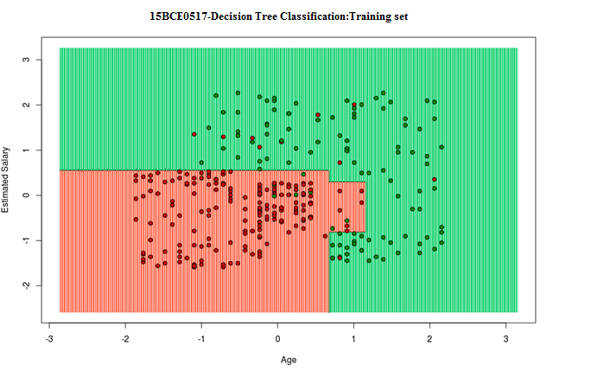

> library(ElemStatLearn)
> set = test_set
> X1 = seq(min(set[, 1]) - 1, max(set[, 1]) + 1, by = 0.01)
> X2 = seq(min(set[, 2]) - 1, max(set[, 2]) + 1, by = 0.01)
> grid_set = expand.grid(X1, X2)
> colnames(grid_set) = c('Age', 'EstimatedSalary')
> y_grid = predict(classifier, newdata = grid_set, type = 'class')
> plot(set[, -3], main = '15BCE0099-Decision Tree Classification:Test set',
+ xlab = 'Age', ylab = 'Estimated Salary',
+ xlim = range(X1), ylim = range(X2))
> contour(X1, X2, matrix(as.numeric(y_grid), length(X1), length(X2)), add = TRUE)
> points(grid_set, pch = '.', col = ifelse(y_grid == 1, 'springgreen3', 'tomato'))
> points(set, pch = 21, bg = ifelse(set[, 3] == 1, 'green4', 'red3'))

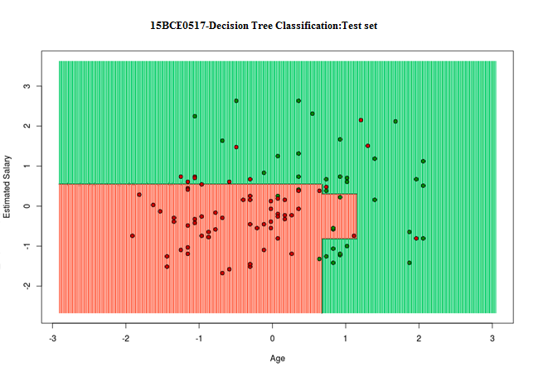

FORMING OF DECISION TREE WITHOUT FEATURE SCALING

> dataset = read.csv('Social_Network_Ads.csv')
> dataset = dataset[3:5]
> dataset$Purchased = factor(dataset$Purchased, levels = c(0, 1))
> library(caTools)
> set.seed(123)
> split = sample.split(dataset$Purchased, SplitRatio = 0.75)
> training_set = subset(dataset, split == TRUE)
> test_set = subset(dataset, split == FALSE)
> library(rpart)
> classifier = rpart(formula = Purchased ~ .,
+ data = training_set)
>
> y_pred = predict(classifier, newdata = test_set[-3], type = 'class')
> plot(classifier)
> text(classifier)

SCREENSHOT OF TRAINING DATA:

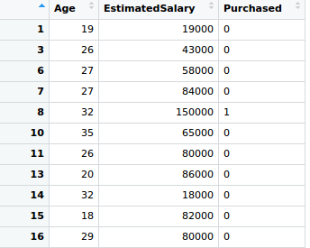

SCREENSHOT OF TEST DATA:

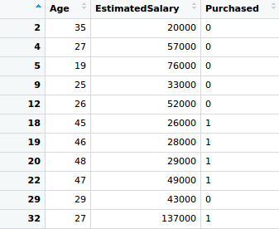

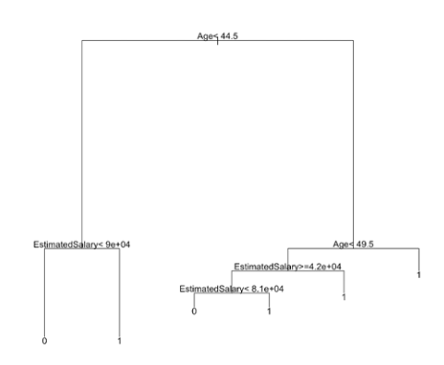

Naïve bayes:

> dataset=read.csv('/home/sanjay/Desktop/Machine Learning A-Z Template Folder/Part 3 - Classification/Section 19 – Naive Bayes Classification/Naive_Bayes/Social_Network_Ads.csv')
> View(dataset)

PREPROCCESING AND FEATURE SCALING

> dataset = read.csv('/home/sanjay/Desktop/Machine Learning A-Z Template Folder/Part 3 - Classification/Section 18 - Naive Bayes/Naive_Bayes/Social_Network_Ads.csv')
> dataset = dataset[3:5]
> dataset$Purchased = factor(dataset$Purchased, levels = c(0, 1))
> set.seed(123)
> split = sample.split(dataset$Purchased, SplitRatio = 0.75)
> training_set = subset(dataset, split == TRUE)
> test_set = subset(dataset, split == FALSE)
> training_set[-3] = scale(training_set[-3])
> test_set[-3] = scale(test_set[-3])

SCREENSHOT OF TRAINING DATA:

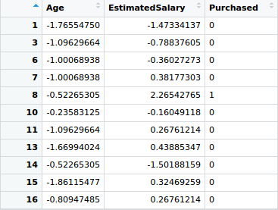

SCREENSHOT OF TEST DATA:

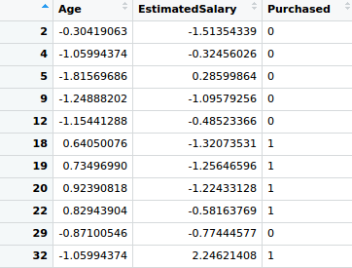

> library(e1071)
> classifier = naiveBayes(x = training_set[-3],
+ y = training_set$Purchased)
> y_pred = predict(classifier, newdata = test_set[-3])
> cm = table(test_set[, 3], y_pred)

PREDICTED VALUES:

CONFUSION MATRIX:

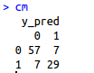

> library(ElemStatLearn)
> set = training_set
> X1 = seq(min(set[, 1]) - 1, max(set[, 1]) + 1, by = 0.01)
> X2 = seq(min(set[, 2]) - 1, max(set[, 2]) + 1, by = 0.01)
> grid_set = expand.grid(X1, X2)
> colnames(grid_set) = c('Age', 'EstimatedSalary')
> y_grid = predict(classifier, newdata = grid_set)
> plot(set[, -3],
+ main = ' 15BCE0517-Naive Bayes (Training set)',
+ xlab = 'Age', ylab = 'Estimated Salary',
+ xlim = range(X1), ylim = range(X2))
> contour(X1, X2, matrix(as.numeric(y_grid), length(X1), length(X2)), add = TRUE)
> points(grid_set, pch = '.', col = ifelse(y_grid == 1, 'springgreen3', 'tomato'))
> points(set, pch = 21, bg = ifelse(set[, 3] == 1, 'green4', 'red3'))

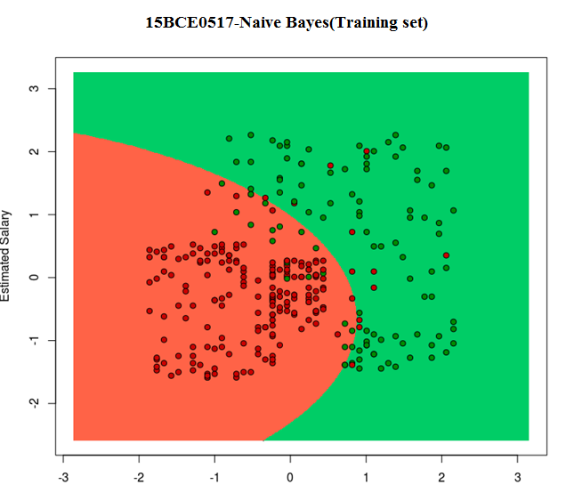

> library(ElemStatLearn)
> set = test_set
> X1 = seq(min(set[, 1]) - 1, max(set[, 1]) + 1, by = 0.01)
> X2 = seq(min(set[, 2]) - 1, max(set[, 2]) + 1, by = 0.01)
> grid_set = expand.grid(X1, X2)
> colnames(grid_set) = c('Age', 'EstimatedSalary')
> y_grid = predict(classifier, newdata = grid_set)
> plot(set[, -3], main = '15BCE0099-Naive Bayes (Test set)',
+ xlab = 'Age', ylab = 'Estimated Salary',
+ xlim = range(X1), ylim = range(X2))
> contour(X1, X2, matrix(as.numeric(y_grid), length(X1), length(X2)), add = TRUE)
> points(grid_set, pch = '.', col = ifelse(y_grid == 1, 'springgreen3', 'tomato'))
> points(set, pch = 21, bg = ifelse(set[, 3] == 1, 'green4', 'red3'))

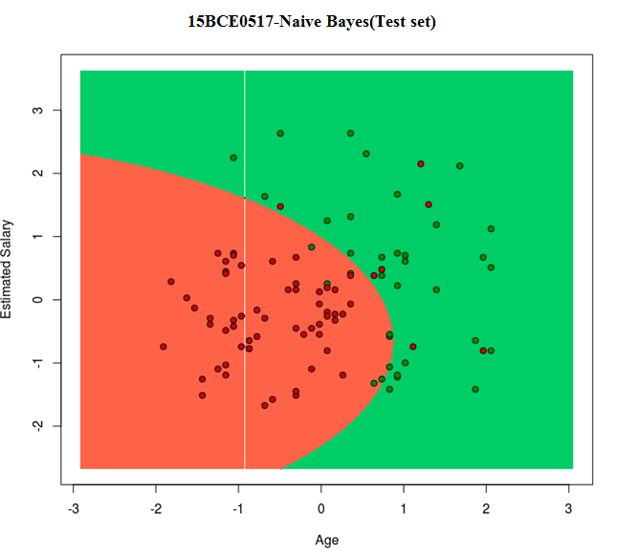

K-nearest neighbours

> dataset=read.csv('/home/sanjay/Desktop/Machine Learning A-Z Template Folder/Part 3 - Classification/Section 19 - KNN Classification/K_Nearest_Neighbours/Social_Network_Ads.csv')
> View(dataset)

PREPROCCESING AND FEATURE SCALING

> dataset = read.csv('/home/sanjay/Desktop/Machine Learning A-Z Template Folder/Part 3 - Classification/Section 18 - KNN/K_Nearest_Neighbour/Social_Network_Ads.csv')
> dataset = dataset[3:5]
> dataset$Purchased = factor(dataset$Purchased, levels = c(0, 1))
> library(caTools)
> set.seed(123)
> split = sample.split(dataset$Purchased, SplitRatio = 0.75)
> training_set = subset(dataset, split == TRUE)
> test_set = subset(dataset, split == FALSE)
> training_set[-3] = scale(training_set[-3])
> test_set[-3] = scale(test_set[-3])

TRAINING DATA:

TEST DATA:

> library(class)
> y_pred = knn(train = training_set[, -3],
+ test = test_set[, -3],
+ cl = training_set[, 3],
+ k = 5,
+ prob = TRUE)
>
> cm = table(test_set[, 3], y_pred)

RESULTS:

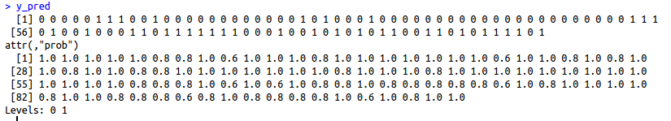

CONFUSION MATRIX:

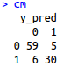

> library(ElemStatLearn)
> set = training_set
> X1 = seq(min(set[, 1]) - 1, max(set[, 1]) + 1, by = 0.01)
> X2 = seq(min(set[, 2]) - 1, max(set[, 2]) + 1, by = 0.01)
> grid_set = expand.grid(X1, X2)
> colnames(grid_set) = c('Age', 'EstimatedSalary')
> y_grid = knn(train = training_set[, -3], test = grid_set, cl = training_set[, 3], k = 5)
> plot(set[, -3],
+ main = ' 15BCE0517-K-NN (Training set)',
+ xlab = 'Age', ylab = 'Estimated Salary',
+ xlim = range(X1), ylim = range(X2))
> contour(X1, X2, matrix(as.numeric(y_grid), length(X1), length(X2)), add = TRUE)
> points(grid_set, pch = '.', col = ifelse(y_grid == 1, 'springgreen3', 'tomato'))
> points(set, pch = 21, bg = ifelse(set[, 3] == 1, 'green4', 'red3'))

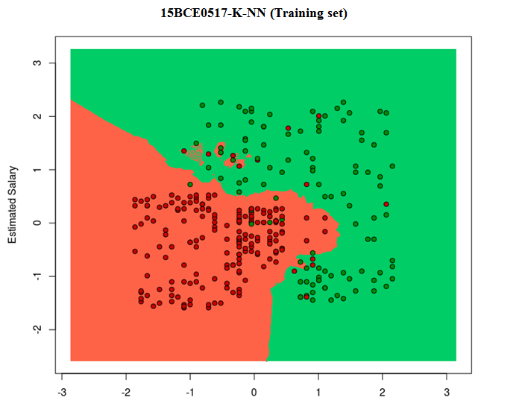

> library(ElemStatLearn)
> set = test_set
> X1 = seq(min(set[, 1]) - 1, max(set[, 1]) + 1, by = 0.01)
> X2 = seq(min(set[, 2]) - 1, max(set[, 2]) + 1, by = 0.01)
> grid_set = expand.grid(X1, X2)
> colnames(grid_set) = c('Age', 'EstimatedSalary')
> y_grid = knn(train = training_set[, -3], test = grid_set, cl = training_set[, 3], k = 5)
> plot(set[, -3],
+ main = '15BCE0099-K-NN (Test set)',
+ xlab = 'Age', ylab = 'Estimated Salary',
+ xlim = range(X1), ylim = range(X2))
> contour(X1, X2, matrix(as.numeric(y_grid), length(X1), length(X2)), add = TRUE)
> points(grid_set, pch = '.', col = ifelse(y_grid == 1, 'springgreen3', 'tomato'))
> points(set, pch = 21, bg = ifelse(set[, 3] == 1, 'green4', 'red3'))

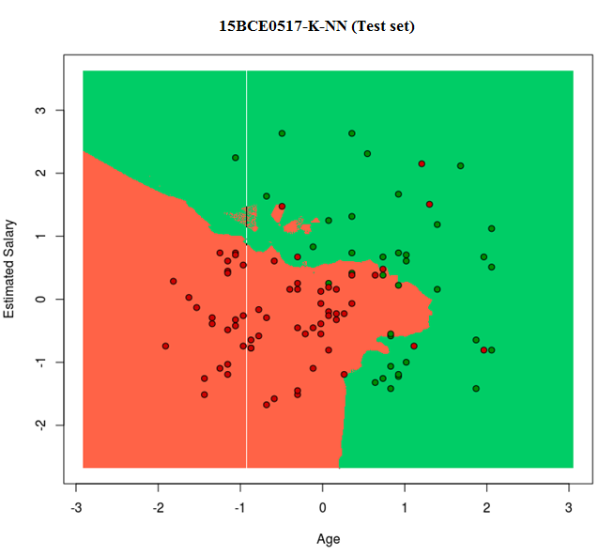

Random forest:

> dataset=read.csv('/home/sanjay/Desktop/Machine Learning A-Z Template Folder/Part 3 - Classification/Section 19 – Random Forest Classification/Random_Forest/Social_Network_Ads.csv')
> View(dataset)

PREPROCCESING AND FEATURE SCALING

> dataset = read.csv('/home/sanjay/Desktop/Machine Learning A-Z Template Folder/Part 3 - Classification/Section 18 – Random Forest/Random_Forest/Social_Network_Ads.csv')
> dataset = dataset[3:5]
> dataset$Purchased = factor(dataset$Purchased, levels = c(0, 1))
> library(caTools)
> set.seed(123)
> split = sample.split(dataset$Purchased, SplitRatio = 0.75)
> training_set = subset(dataset, split == TRUE)
> test_set = subset(dataset, split == FALSE)
> training_set[-3] = scale(training_set[-3])
> test_set[-3] = scale(test_set[-3])

TRAINING DATA:

TEST DATA:

> set.seed(123)
> classifier = randomForest(x = training_set[-3],
+ y = training_set$Purchased,
+ ntree = 500)
> y_pred = predict(classifier, newdata = test_set[-3])
> cm = table(test_set[, 3], y_pred)
> y_pred

SCREENSHOT OF PREDICTED CLASS(0 or 1):

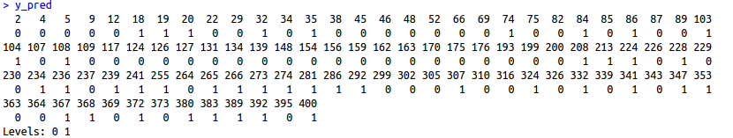

CONFUSION MATRIX:

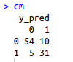

VISUALIZING TRAINING DATA RESULTS

> library(ElemStatLearn)
> set = training_set
> X1 = seq(min(set[, 1]) - 1, max(set[, 1]) + 1, by = 0.01)
> X2 = seq(min(set[, 2]) - 1, max(set[, 2]) + 1, by = 0.01)
> grid_set = expand.grid(X1, X2)
> colnames(grid_set) = c('Age', 'EstimatedSalary')
> y_grid = predict(classifier, grid_set)
> plot(set[, -3],
+ main = ' 15BCE0517-Random Forest Classification (Training set)',
+ xlab = 'Age', ylab = 'Estimated Salary',
+ xlim = range(X1), ylim = range(X2))
> contour(X1, X2, matrix(as.numeric(y_grid), length(X1), length(X2)), add = TRUE)
> points(grid_set, pch = '.', col = ifelse(y_grid == 1, 'springgreen3', 'tomato'))
> points(set, pch = 21, bg = ifelse(set[, 3] == 1, 'green4', 'red3'))

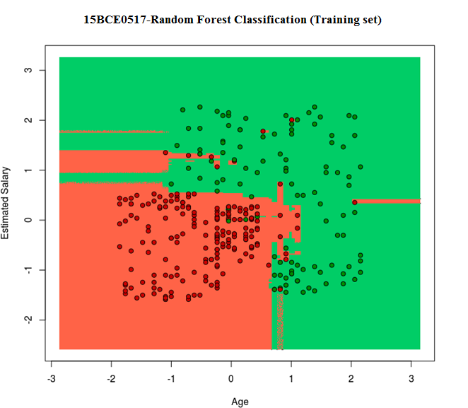
VISUALIZING TEST DATA RESULTS

> library(ElemStatLearn)
> set = test_set
> X1 = seq(min(set[, 1]) - 1, max(set[, 1]) + 1, by = 0.01)
> X2 = seq(min(set[, 2]) - 1, max(set[, 2]) + 1, by = 0.01)
> grid_set = expand.grid(X1, X2)
> colnames(grid_set) = c('Age', 'EstimatedSalary')
> y_grid = predict(classifier, grid_set)
> plot(set[, -3], main = ' 15BCE0517-Random Forest Classification (Test set)',
+ xlab = 'Age', ylab = 'Estimated Salary',
+ xlim = range(X1), ylim = range(X2))
> contour(X1, X2, matrix(as.numeric(y_grid), length(X1), length(X2)), add = TRUE)
> points(grid_set, pch = '.', col = ifelse(y_grid == 1, 'springgreen3', 'tomato'))
> points(set, pch = 21, bg = ifelse(set[, 3] == 1, 'green4', 'red3'))

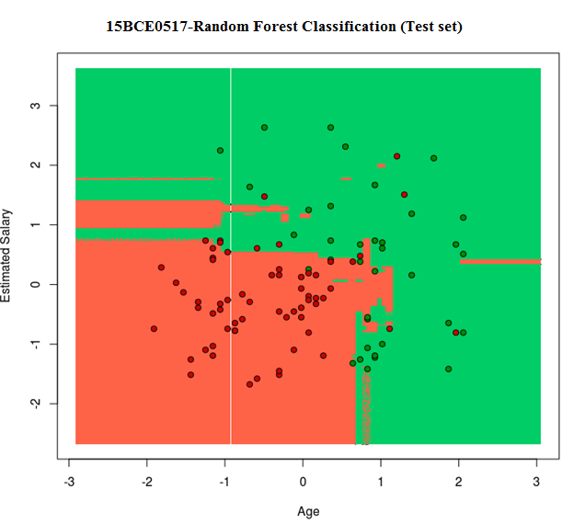

CONFUSION MATRIX OF DECISION TREE

- Number of errors: 11 + 6 = 17

- Toatl number of obervations: 100

- Accuracy rate: 83/100

- Error rate: 17/100

CONFUSION MATRIX OF NAIVE BAYES

- Number of errors: 7 + 7 = 14

- Toatl number of obervations: 100

- Accuracy rate: 86/100

- Error rate: 14/100

CONFUSION MATRIX OF K NEAREST NEIGHBOURS

- Number of errors: 5 + 6 = 11

- Toatl number of obervations: 100

- Accuracy rate: 89/100

- Error rate: 11/100

CONFUSION MATRIX OF RANDOM FOREST

- Number of errors: 5 + 6 = 15

- Toatl number of obervations: 100

- Accuracy rate: 85/100

- Error rate: 15/100

SUMMARY OF THE PERFORMANCE OF ALL CLASSIFIERS FOR THIS DATASET

 | NUMBER OF ERRORS | TOTAL NO OF OBSERVATIONS | ACCURACY RATE | ERROR  RATE
DECISION TREE | 17 | 100 | 0.83 | 0.17
NAIVE BAYES | 14 | 100 | 0.86 | 0.14
K NEAREST NEIGHBOURS | 11 | 100 | 0.89 | 0.11
RANDOM FOREST | 15 | 100 | 0.85 | 0.15

